Ques: Find the average value of current shown graphically, from t = 0 to t = 2 sec.
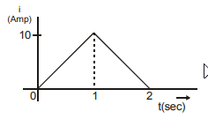

Solution:
From the i – t graph, area from t = 0 to t = 2 sec = 10 Amp. Average current = 10/2 = 5 Amp.

